
Planning Commission
Tuesday, December 08, 2020, at 7:00 PM
Court Room/Council Chambers (2nd Floor) and Online
MEETINGS HELD ONLINE ONLY

Pursuant to recent updates from the Utah State Department of Health regarding the number of people allowed to gather physically for a public meeting, in-person participation will be limited to elected and appointed city officials only. The public is invited to participate electronically as outlined below:

- YouTube Live – Public meetings will be shown live on the Santaquin City YouTube Channel, which can be found at https://www.youtube.com/channel/UCTzZT_yW2H2Hd-58M2_ddSw
or by searching for Santaquin City Channel on YouTube.

PUBLIC COMMENT & PUBLIC HEARING PARTICIPATION
As with all City Council and Planning Commission Meetings, we will continue to invite the public to provide “Public Comment” (30-minute duration, maximum of 5-minutes per comment). We will also continue to hold Public Hearings, as needed, and required on specific issues. We invite the public to provide comment in the following ways:
- By Email – Comments will be accepted by email up to 5:00 P.M. on the date of the meeting. Comments will be read during the meeting and made part of the official record of the city. Comments should be submitted to PublicComment@Santaquin.org
- By Telephone – For those who would like to have their own voice heard during the Public Comment or Public Hearing periods, please submit an email to PublicComment@Santaquin.org providing us your Telephone Number.

ADA NOTICE
If you are planning to attend this Public Meeting and, due to a disability, need assistance in understanding or participating in the meeting, please notify the City Office ten or more hours in advance and we will, within reason, provide what assistance may be required.
AGENDA
WELCOME
INVOCATION/INSPIRATION THOUGHT
PLEDGE OF ALLEGIANCE
ORDER OF AGENDA ITEMS
1. PUBLIC HEARING- Little Readers Academy Home Occupation Conditional Use Permit
The Planning Commission will review a Conditional Use Permit application, for a Major Home Occupation preschool located at 119 W. Badger Way.
2. 2021 Regular Meeting Schedule
The Planning Commission will approve the regular meeting schedule for 2021.
3. Nomination of a New Chair and Vice Chair
The Planning Commission will nominate a new Chair and Vice Chair for 2021.
PUBLIC FORUM
DISCUSSION & POSSIBLE ACTION
OTHER BUSINESS
4. Meeting Minutes Approval
November 24, 2020
ADJOURNMENT

CERTIFICATE OF MAILING/POSTING
The undersigned duly appointed City Recorder for the municipality of Santaquin City hereby certifies that a copy of the foregoing Notice and Agenda was e-mailed to the Payson Chronicle, Payson, UT, 84651, posted on www.santaquin.org, as well as posted on the State of Utah’s Public Website.

BY: | 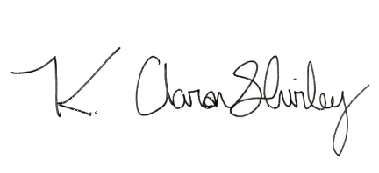
 | K. Aaron Shirley, City Recorder

